SMARTPHONE USAGE & DIGITAL ADDICTION INTELLIGENCE
Smartphone Usage, Digital Addiction and Well-Being Analysis

__________________________________________________________________________________________
FINAL PROJECT REPORT
__________________________________________________________________________________________

AI Specialist — Data Analyst Track
Prepared by: Nakketla Hima Bindu
Date: 21 September 2026

Table of Contents

1. Introduction 3
2. Project Initialization and Planning Phase 3
3. Data Collection and Preprocessing Phase 4
4. Data Visualization 5
5. Dashboard 6
6. Report 7
7. Performance Testing 8
8. Conclusion/Observation 9
9. Future Scope 9
10. Appendix 10

Smartphone Usage, Digital Addiction & Well-Being Analytics

1. Introduction
1.1. Project overviews
This project analyzes smartphone usage behavior across 7,500 users to understand how screen time, notifications, sleep, and other digital habits relate to smartphone addiction and overall well-being. The workflow covers SQL-based data exploration, Power BI data preparation, KPI creation, visualization, and dashboard/report development, concluding with documented findings and recommendations.
1.2. Objectives
- Identify which behavioral factors are most strongly linked to smartphone addiction.
- Build KPIs and DAX measures to quantify addiction rate, screen time, and sleep patterns.
- Create interactive Power BI visualizations to explore trends, comparisons, and relationships.
- Develop a dashboard and report to communicate findings to a non-technical audience.
- Document the full workflow and present actionable insights and recommendations.
2. Project Initialization and Planning Phase
2.1. Define Problem Statement
PS | I am | I'm trying to | But | Because | Which makes me feel
PS-1 | a college student using my phone throughout the day | stay focused on studies and get enough sleep | I keep losing hours to notifications and social media | the phone sends frequent notifications and apps encourage repeated opens | distracted, tired, and guilty
PS-2 | a parent/well-being coach guiding young users | identify who is at risk of addiction and why | there is no simple, data-backed way to see which patterns predict addiction | the data is scattered and not analyzed into clear KPIs | unable to give timely, evidence-based advice

2.2. Project Proposal (Proposed Solution)
Objective: Analyze smartphone usage data from 7,500 users to identify which behavioral factors are most strongly linked to addiction, presented through an interactive Power BI dashboard.
Approach: Clean and explore the dataset using SQL; prepare data in Power BI using Power Query; build DAX measures for key KPIs; create visualizations comparing addicted vs. non-addicted users; assemble an interactive dashboard with supporting documentation.
2.3. Initial Project Planning
The project was planned across 4 sprints covering 12 user stories: Data Collection & SQL Analysis (Sprint 1), Power BI Data Prep & KPI Creation (Sprint 2), Data Visualization, Dashboard, and Report Development (Sprint 3), and Performance Testing & Documentation (Sprint 4).
3. Data Collection and Preprocessing Phase
3.1. Data Collection Plan and Raw Data Sources Identified
The primary raw data source is Smartphone_Usage.csv, containing 7,500 rows and 16 columns covering demographics, usage behavior, well-being indicators, and addiction labels. The file was loaded into a MySQL database (smartphone_usage) for SQL-based exploration, then imported into Power BI via Power Query.
3.2. Data Quality Report
A null check across key fields (age, daily_screen_time_hours, addiction_level) found no missing values in age or screen time. The addiction_level column has 819 blank values, all belonging to users with addicted_label = 0 - not a data quality issue, since non-addicted users are simply not assigned a severity label.
3.3. Data Exploration and Preprocessing
In Power BI, data types were verified for all columns, and an Age Band calculated column was added to segment users (Under 20, 20-29, 30-39, 40-49, 50+). Eleven DAX measures were created, including Total Users, Addicted Users, Addiction Rate %, Avg Daily/Weekend Screen Time, Avg Sleep Hours, Avg Notifications Per Day, and split comparisons (Addicted vs Non-Addicted) for sleep and screen time.
4. Data Visualization
4.1. Framing Business Questions
- What percentage of users show addicted usage patterns?
- How does daily screen time differ between addicted and non-addicted users?
- Is there a relationship between daily screen time and sleep hours?
- How is addiction severity distributed across users?
- Does weekend screen time differ from weekday screen time?
- Does addiction rate vary by age group?
- Does stress level relate to addiction status?
- Which factor has the strongest relationship with addiction - screen time or notifications?
4.2. Developing Visualizations
Chart | Type | Fields Used
KPI Cards | Card | Total Users, Addicted Users, Addiction Rate %
Addiction Rate by Age Band | Bar Chart | Age Band, Addiction Rate %
Screen Time: Addicted vs Non-Addicted | Bar Chart | Avg Screen Time measures
Sleep: Addicted vs Non-Addicted | Bar Chart | Avg Sleep Hours measures
Screen Time vs Sleep Hours | Scatter Chart | daily screen time, sleep hours
Addiction Level Breakdown | Donut/Pie Chart | addiction level
Weekday vs Weekend Screen Time | Bar Chart | daily vs weekend screen time
Notifications Distribution | Line Chart | notifications per day

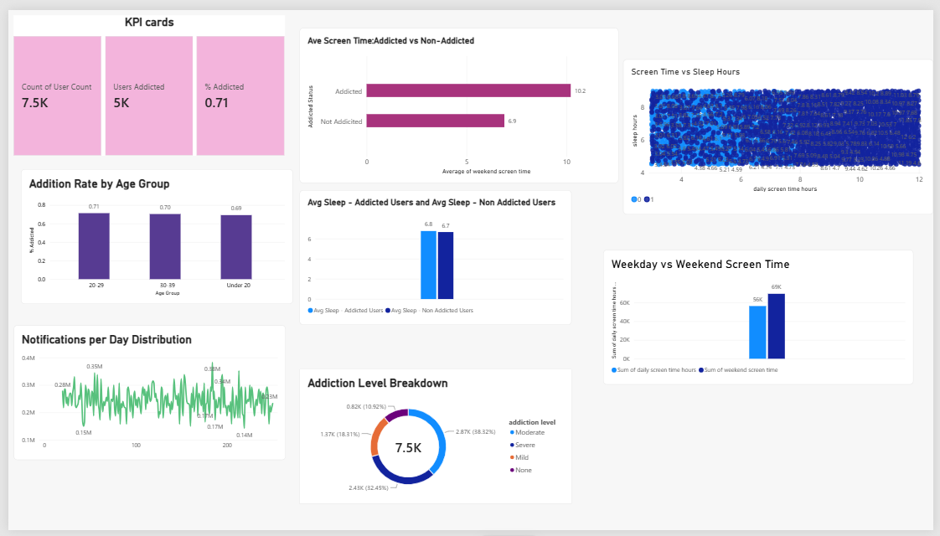
5. Dashboard
5.1. Dashboard Design Screenshot with Insights
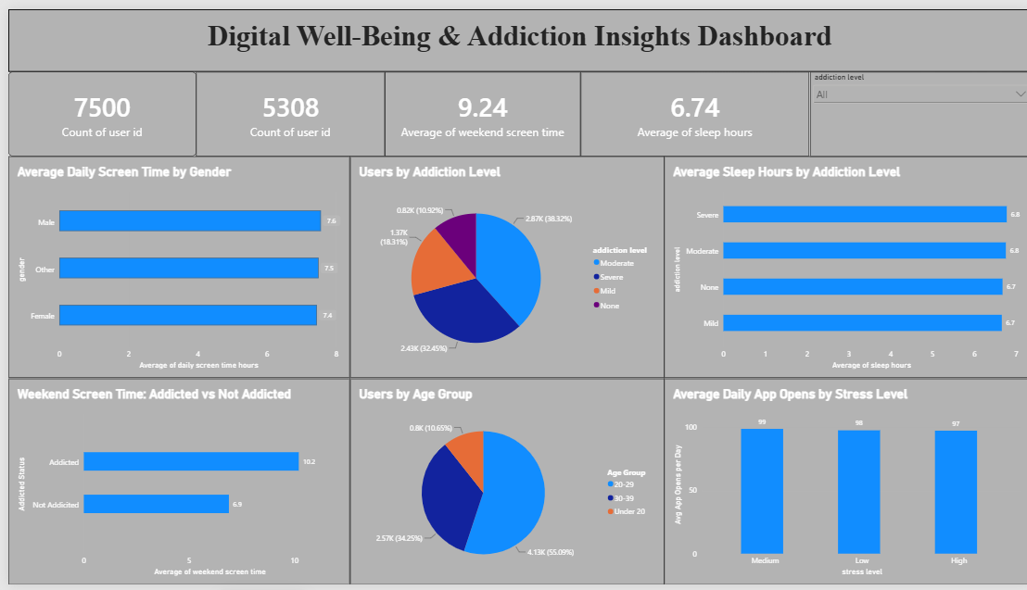
- Total Users Analyzed: 7,500 users, with 5,308 (70.8%) showing addicted usage patterns.
- Addiction Severity Distribution: Moderate 38.32%, Severe 32.45%, Mild 18.31%, None 10.92%.
- Weekend Usage Gap: Addicted users average 10.2 hrs weekend screen time vs 6.9 hrs for non-addicted.
- Age Group Concentration: Users aged 20-29 make up 55.09% of the dataset.
- Sleep hours stay nearly flat (6.7-6.8 hrs) across addiction levels - screen time is the key differentiator.

6. Report
6.1. Report Design Screenshot with Insights
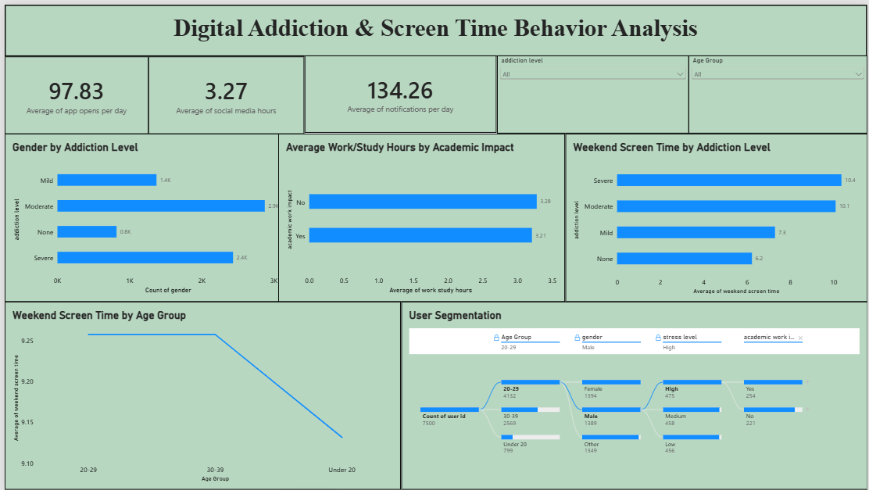
- Trends Over Time: Weekend screen time peaks in the 20-29 age group (9.25 hrs).
- Performance Comparisons: Weekend screen time rises with addiction severity - Severe 10.4 hrs vs None 6.2 hrs.
- Customer Segmentation: Decomposition tree shows 4,132 users aged 20-29, of whom 1,394 are Female and 475 report High stress.
- Goal Achievement: Engagement KPIs (134.26 notifications/day, 97.83 app opens/day) tracked as digital engagement indicators.
Key Influencers Analysis - What Influences Addicted Status: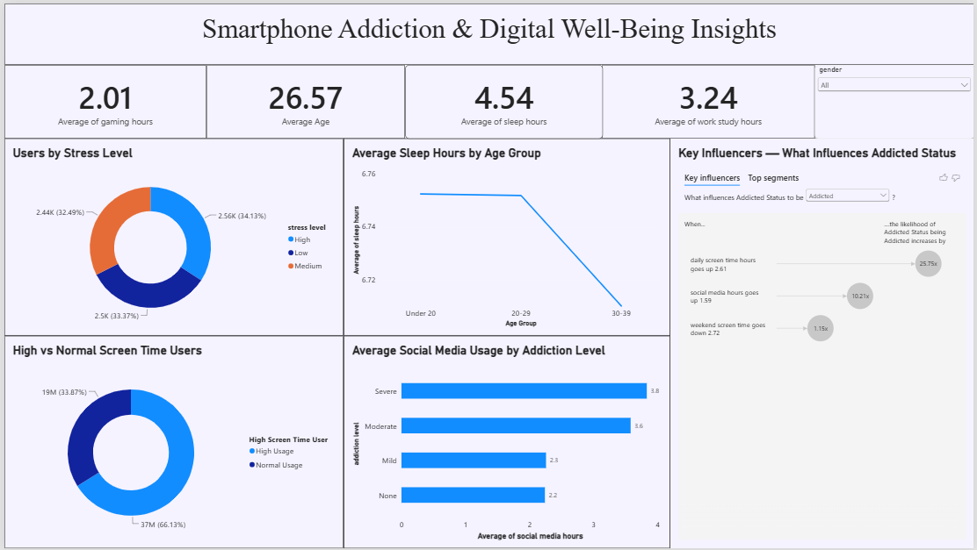

- When daily screen time hours goes up by 2.61, the likelihood of Addicted status increases by 25.75x - the single strongest influencer identified.
- When social media hours goes up by 1.59, the likelihood of Addicted status increases by 10.21x.
- When weekend screen time goes down by 2.72, the likelihood of Addicted status increases by only 1.15x - a much weaker effect than weekday screen time or social media use.
- Average social media usage also scales with addiction severity: Severe 3.8 hrs, Moderate 3.6 hrs, Mild 2.3 hrs, None 2.2 hrs.
- Users are split 66.13% Normal Usage vs 33.87% High Screen Time Usage.

7. Performance Testing
7.1 Utilization of Data filters
The dashboard includes an Addiction Level slicer, and the Report page includes a multi-level decomposition tree filter (Age Group, gender, stress level, academic/work impact) enabling dynamic, drill-through exploration of the data.
7.2 No of Calculation Columns/Measures
1 calculated column (Age Band) and 11 DAX measures were created (Total Users, Addicted Users, Addiction Rate %, Avg Daily Screen Time, Avg Weekend Screen Time, Avg Sleep Hours, Avg Notifications Per Day, Avg Sleep - Addicted/Non-Addicted, Avg Screen Time - Addicted/Non-Addicted).
7.3 No of Visualization
Across all report pages (kpi cards, Kpis, Dashboard, Report 1, Report 2), the project includes over 30 visuals in total: KPI cards, clustered bar/column charts, pie/donut charts, a scatter chart, a line chart, slicers, a decomposition tree, and a Key Influencers visual identifying the top drivers of addiction with quantified likelihood multipliers.

8. Conclusion/Observation
Key Finding: Screen time and social media usage - not demographics, stress, or sleep - drive smartphone addiction in this population.
- Evidence: The Key Influencers analysis quantifies this precisely - a rise in daily screen time increases the odds of addiction by 25.75x, and a rise in social media hours increases it by 10.21x. Weekend screen time, by comparison, shows only a 1.15x effect - a much weaker signal.
- Evidence: Addiction severity scales directly with both screen time and social media hours (e.g., social media use rises from 2.2 hrs for 'None' to 3.8 hrs for 'Severe' addiction), while sleep hours, stress level, gender, and age band all stay nearly flat across addiction status - ruling them out as meaningful drivers.
- Evidence: 70.8% of the 7,500 users analyzed already show addicted usage patterns, and 33.87% fall into the 'High Screen Time User' category - confirming this is a widespread, not isolated, pattern.
Recommendation: Interventions and awareness efforts should focus specifically on reducing daily screen time and social media usage, since these are the two levers with measurable impact on addiction likelihood. Broad messaging around sleep, stress management, or weekend habits is unlikely to move the needle on its own, based on what this data shows.
9. Future Scope
- Incorporate time-series data to track the same users over time and establish causal direction.
- Add drill-down hierarchies and a mobile-responsive layout to the dashboard.
- Expand the dataset with additional behavioral or app-category-level data for deeper segmentation.
- Build a predictive model to flag at-risk users based on screen time trends.
10. Appendix
10.1. Source Code(if any)
SQL queries:
create database smartphone_usage;
use smartphone_usage;

select * from smartphone_usage;

select count(*) from smartphone_usage;

-- null values
SELECT * FROM smartphone_usage
WHERE age IS NULL OR daily_screen_time_hours IS NULL OR addiction_level IS NULL;

-- Gender-level addiction counts
SELECT gender, COUNT(*), SUM(CASE WHEN addicted_label = 1 THEN 1 ELSE 0 END) AS addicted_count
FROM smartphone_usage
GROUP BY gender;

-- Baseline usage averages
SELECT AVG(daily_screen_time_hours), AVG(sleep_hours), AVG(stress_level = 'High')
FROM smartphone_usage;

-- Stress level comparison by addiction status
SELECT addicted_label, stress_level, COUNT(*)
FROM smartphone_usage
GROUP BY addicted_label, stress_level
ORDER BY addicted_label, stress_level;

-- Addiction level distribution
SELECT addiction_level, COUNT(*), AVG(daily_screen_time_hours), AVG(sleep_hours)
FROM smartphone_usage
GROUP BY addiction_level;

-- Screen time comparison by academic/work impact
SELECT academic_work_impact, AVG(daily_screen_time_hours), AVG(social_media_hours), AVG(gaming_hours)
FROM smartphone_usage
GROUP BY academic_work_impact;

10.2. GitHub & Project Demo Link
GitHub Repository: [https://github.com/HimaBindu9173/Smartphone-Usage-Digital-Addiction-Well-Being-Analytics/tree/main]
Project Demo Video: [insert your demo video link here]

